**SEC: More Accurate Clustering Algorithm via Structural Entropy**

**Junyu Huang**1, 2 **, Qilong Feng**1, 2, * **, Jiahui Wang**1, 2 **, Ziyun Huang**3 **, Jinhui Xu**4 **, Jianxin Wang**1, 2, 5, *

1 School of Computer Science and Engineering, Central South University, Changsha 410083, China

2 Xiangjiang Laboratory, Changsha 410205, China

3 Department of Computer Science and Software Engineering, Penn State Erie, The Behrend College

4 Department of Computer Science and Engineering, State University of New York at Buffalo, NY, USA

5 The Hunan Provincial Key Lab of Bioinformatics, Central South University, Changsha 410083, China

junyuhuangcsu@foxmail.com, csufeng@mail.csu.edu.cn, 224711099@csu.edu.cn, zxh201@psu.edu,jinhui@buffalo.edu,

jxwang@mail.csu.edu.cn

**Abstract**

As one of the most popular machine learning tools in the feld of unsupervised learning, clustering has been widely used in various practical applications. While numerous methods have been proposed for clustering, a commonly encountered issue is that the existing clustering methods rely heavily on local neighborhood information during the optimization pro- cess, which leads to suboptimal performance on real-world datasets. Besides, most existing clustering methods use Eu- clidean distances or densities to measure the similarity be- tween data points. This could constrain the effectiveness of the algorithms for handling datasets with irregular patterns. Thus, a key challenge is how to effectively capture the global structural information in clustering instances to improve the clustering quality. In this paper, we propose a new cluster- ing algorithm, called SEC. This algorithm uses the global structural information extracted from an encoding tree to guide the clustering optimization process. Based on the re- lation between data points in the instance, a sparse graph of the clustering instance can be constructed. By leveraging the sparse graph constructed, we propose an iterative encoding tree method, where hierarchical abstractions of the encoding tree are iteratively extracted as new clustering features to ob- tain better clustering results. To avoid the infuence of easily misclustered data points located on the boundaries of the clus- tering partitions, which we call “fringe points”, we propose an iterative pre-deletion and reassignment technique such that the algorithm can delete and reassign the “fringe points” to obtain more resilient and precise clustering results. Empir- ical experiments on both synthetic and real-world datasets demonstrate that our proposed algorithm outperforms state- of-the-art clustering methods and achieves better clustering performances. On average, the clustering accuracy (ACC) is increased by 1.7% and the normalized mutual informa- tion (NMI) by 7.9% compared with the current state-of-the- art (SOTA) algorithm on synthetic datasets. On real-world datasets, our method outperforms other clustering methods with an average increase of 12.3% in ACC and 5.2% in NMI, respectively.

* Corresponding Authors

Copyright © 2024, Association for the Advancement of Artifcial Intelligence (www.aaai.org). All rights reserved.

**Introduction**

As a widely studied unsupervised learning task, clustering involves partitioning data points into different clusters ac- cording to their similarity such that data points within the same cluster share high similarity as much as possible. By modeling clustering tasks as optimization problems, sev- eral classic clustering methods have been proposed, such as Lloyd-type methods, DBSCAN, hierarchical clustering and MST clustering. However, a recurring limitation of the existing methods is that they only use local neighborhood information during the optimization process. Furthermore, most existing clustering methods use Euclidean distances or clustering densities to measure the similarity between data points. These clustering methods might fail to capture the intrinsic global patterns of the given clustering instances, which could constrain the effectiveness of the algorithms for handling datasets with irregular patterns. Consequently, a critical challenge for achieving better clustering perfor- mance lies ineffective integration of global structural infor- mation into the clustering optimization process.

As pointed out in (Du and Wang 2022), global structural information of the data points represents the high-level pat- terns and relationships across the entire dataset. Recently, a new metric based on the graph’s structural information, known as structural entropy, was introduced to analyze the hierarchical structure of graphs. This metric utilizes an en- coding tree approach, offering a novel perspective in graph analysis (Li and Pan 2016). By minimizing the structural en- tropy of the given graph, an encoding tree can be constructed where each node of the encoding tree is associated with a partition of the graph. In general, the encoding tree provides hierarchical abstractions of the graph, allowing the preser- vation of global structural information within its nodes.

For many datasets, the clustering performance is closely related to the distinctiveness between clusters. To enlarge the distinctiveness between clusters, we present an encoding- tree-based structural metric where global structural infor- mation of the given data points can be captured to guide the clustering process. Firstly, we design a new sparse graph embedding technique for clustering instances using k- Nearest Neighbor (k-NN) and thresholding strategies. k-NN and thresholding strategies help to identify the most rele-

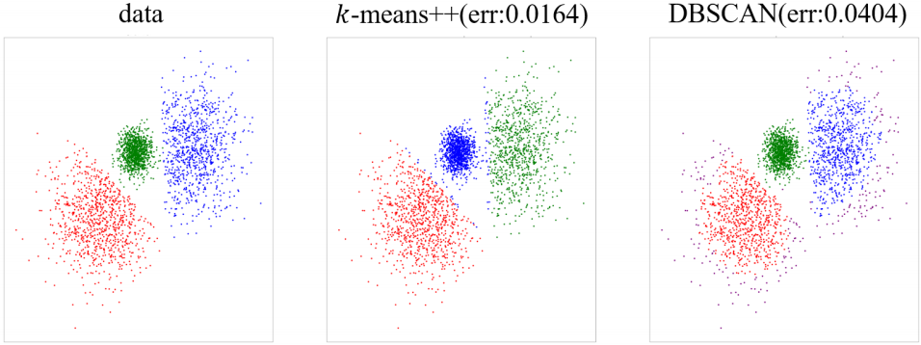The Thirty-Eighth AAAI Conference on Artiﬁcial Intelligence (AAAI-24)

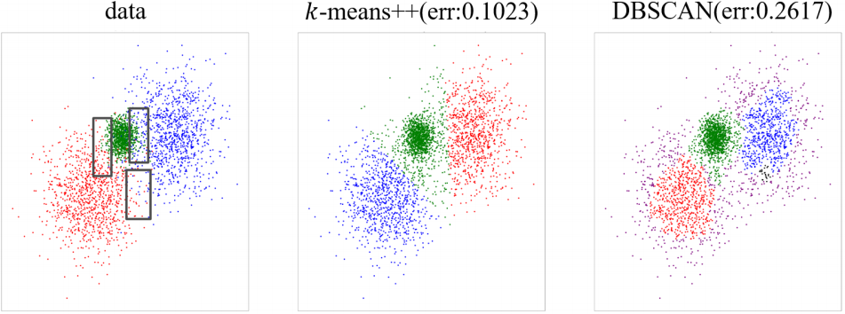

(a) Comparisons of clustering performances on k-means++ and (b) Comparisons of clustering performances on k-means++ and DBSCAN with the “fringe set” . DBSCAN without the “fringe set” .

Figure 1: Comparisons of clustering performances on k-means++ and DBSCAN with and without the “fringe set”, where the blackbox represents the locations for the “fringe set” . The error rate for clustering is given fork-means++ and DBSCAN in the fgure.

vant neighbors while removing irrelevant neighbors for each node in the graph, which can provide potentially better local and global learnable structures for encoding tree. Secondly, in order to obtain complex and non-linear structures, we pro- pose an iterative encoding tree method, where hierarchical abstractions of the encoding tree are iteratively extracted as new clustering features to better represent the intrinsic hid- den relationships of the given datasets.

For the clustering problem, empirical observations sug- gest that most of themisclustered data points locate on the boundaries of the clustering partitions, which we call the “fringe set” . Figure 1 gives illustrations to show the im- pact of the fringe set for clustering problem. It can be seen that the fringe set presents signifcant assignment challenges for classic clustering methods such as k-means++ and DB- SCAN. The existence of the fringe set can signifcantly de- teriorate the performance of classic clustering methods. In order to enhance the capability of the proposed algorithm to better identify and assign data points in the fringe set, we propose an iterative pre-deletion and reassignment method that can identify, delete, and reassign data points in the fringe set during the clustering optimization process. By us- ing this method, interference caused by the fringe set can be alleviated to obtain a more resilient and precise clustering partition. The main contributions of this paper are summa- rized as follows:

• We propose a new sparse graph embedding method for clustering instances. The proposed graph embedding method can provide a better representation of the rela- tionships between the given data points.

• Based on the sparse graph obtained, we propose an it- erative encoding tree method to extract global structural information from the given clustering instances. The pro- posed feature extraction method provides iterative hier- archical abstractions of the encoding tree structure, en- hancing the algorithm’s capability to capture the hidden relationships within the entire dataset.

• We propose an iterative pre-deletion and reassignment technique such that the fringe set can be identifed, deleted and reassigned during the clustering optimiza- tion process. With this technique, the interference of the fringe set can be alleviated to obtain better clustering re-

sults.

• Empirical experiments demonstrate that the proposed SEC algorithm outperforms other state-of-the-art clus- tering methods in terms of clustering quality. The aver- age clustering performance shows an increase of 12.3% in ACC and 5.2% in NMI on real-world datasets. In par- ticular, for a specifc subset of these real-world datasets, the clustering ACC and NMI are increased by 20.6% and 9.8%,respectively.

**Related Work**

**Lloyd-Type Clustering Methods**

The main idea behind Lloyd-type clustering methods is to iteratively assign data points to the nearest clustering cen- troids and update the centroids to minimize the sum of the squared distances. However, as pointed out in (Blmer et al. 2016), Lloyd-type methods (Lloyd 1982) are highly sen- sitive to the initialization. Arthur and Vassilvitskii (Arthur and Vassilvitskii 2007) proposed the k-means++ seeding method, which uses D2 -sampling strategy to achieve an O(log k)-approximation guarantee on clustering quality. Lattanzi and Sohler (Lattanzi and Sohler 2019) proposed a combination of local search and k-means++ method, which can yield a constant approximation in linear running time. A distinct line of work for obtaining better initialization is to integrate heuristic strategies into Lloyd-type methods (Li and Wu 2012; Mawati, Sumertajaya, and Afendi 2014; Zhou et al. 2017; Nainggolan et al. 2019; Yang et al. 2021; Huang et al. 2021). However, they still rely heavily on the local neighborhood information for clustering optimization.

**MST Clustering Methods**

MST clustering aims to create a minimum spanning tree (MST) through iterative connections of data points with minimum edge weights. Clustering partitions can be ob- tained by cutting inconsistent edges with larger weights. For MST clustering methods, Zahn (Zahn 1971) defned incon- sistent edges as those edges with weights signifcantly larger than the average weight of neighboring edges. Chowdhury and Murthy (Chowdhury and Murthy 1997) proposed a new measurement of inconsistency based on the identifcation of

The Thirty-Eighth AAAI Conference on Artiﬁcial Intelligence (AAAI-24)

the boundaries separating distinct clusters. By integrating lo- cal density information, several density-based MST cluster- ing methods were proposed, such as the LDP-MST method (Cheng et al. 2019), which avoids the infuence of noisy points and reduces the running time.

**Density-Based Clustering Methods**

Density-Based clustering methods (DB methods) form clus- tering partitions according to the density of the data points. DBSCAN (Ester et al. 1996) is one of the most widely used methods that quantifes the density of data points using lo- cal neighborhood information. However, as pointed out in (Bhattacharjee and Mitra 2021), DBSCAN is highly sensi- tive to the search radius of local neighborhoods. In (Ram et al. 2010) and (Campello, Moulavi, and Sander 2013), density fuctuations within the same cluster were considered during the DBSCAN process to improve the algorithm’s ro- bustness. In (Ankerst et al. 1999) and (Hou, Gao, and Li 2016), parameter-adaptive and non-parametric versions of DBSCAN methods were proposed.

**Hierarchical Clustering Methods**

Hierarchical clustering mainly falls into two categories: di- visive and agglomerative methods. The divisive approach starts with a single cluster that encompasses all data points and iteratively splits this cluster into smaller clusters until each cluster contains a single data point. The agglomerative approach iteratively merges the most similar clusters until a single cluster containing all the data points is formed. Stein- bach, Karypis, and Kumar (Steinbach, Karypis, and Kumar 2000) used the k-means method to iteratively form smaller clusters. Gracia and Binefa (Gracia and Binefa 2011) mod- ifed the defnition of the k-means objective function to achieve better performance. (Sneath 1973) used the Eu- clidean distance to defne the similarity when performing merging operations. (Yang et al. 2023) used local density to improve the merging process for hierarchical clustering methods.

**Preliminaries**

Given an integer n ∈ Z+ , denote [n] as the set {1, 2,..., n}. Given a set X = {xi |i ∈ [n]} of data points and a la- beling partition C = {cj |j ∈ [k]}, for any data point xi , let li = (li1,...,lik ) be the binary vector denoting which cluster xi is assigned to, where lij = 1 if xi is in the j-th cluster, otherwise lij = 0. Given an undirected weighted graph G = (V,E, W), where V is the vertex set, E is the edge set, and W : E → R+ is the weight func- tion of edges, let VOL = εe∈E W(e) be the sum of the weights of edges. For each v ∈ V, we denote the sum of the weights of its connected edges as vol(v). For a point ci with li = {li1,...,lik }, the center cj for the j-th cluster is defned as cj = εi∈[n] lij xi / εi∈[n] lij .

**Clustering with Global Structural Feature**

For clustering tasks, existing clustering methods commonly rely on the pairwise distances and densities to group the data points into clusters. Thus, a fundamental challenge is how

to effectively incorporate global structural features into the clustering optimization process.

In this section, we present a new algorithm called the SEC algorithm (Algorithm 1), which integrates structural entropy to capture the global structural features of the clustering in- stances. The SEC algorithm mainly consists of three parts: (1) sparse graph embedding (lines 2-3 of Algorithm 1); (2) structural entropy extraction (lines 4-5 of Algorithm 1); (3) iterative pre-deletion and reassignment (line 7 of Algorithm 1). Figure 2 provides a graph illustration to show how the algorithm works.

The proposed sparse graph embedding method adapts the k-NN and thresholding strategies for graph sparsifcation. In the structural entropy extraction phase, an encoding tree is frst constructed based on the obtained graph embedding. Each vertex of the encoding tree represents a graph parti- tion determined by the structural entropy of the graph nodes. Then, we propose an iterative encoding tree method to ob- tain global structural features by iteratively augmenting the dimension of the raw dataset and adjusting the tree structure.

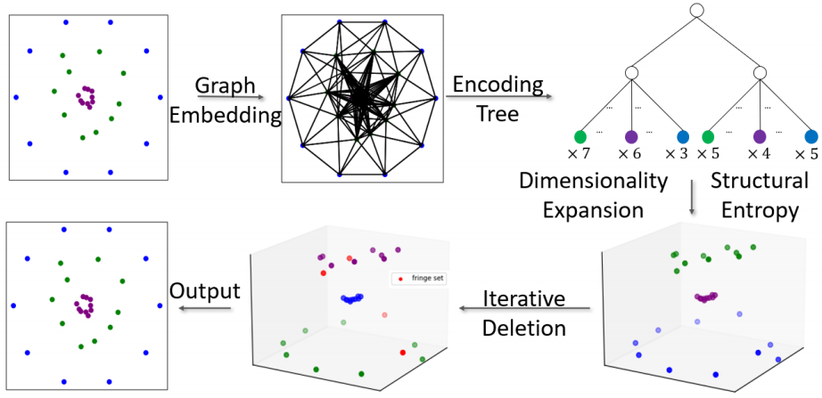

Figure 2: A graph illustration on how Algorithm 1 works

To avoid the infuence of easily misclustered data points, we propose a new defnition called the fringe set to fnd data points that are located in the regions consisting of multiple distinct clusters and share similar structural entropy. Data points in the fringe set are inherently diffcult to separate. To overcome this challenge, in the iterative pre-deletion and re- assignment phase, we propose a fringe set exclusion method, which can identify, delete, and reassign the fringe points dur- ing the clustering optimization process.

**Graph Embedding**

For the clustering problem, a natural way of graph embed- ding is to represent the given dataset as a complete graph, where the weight between any two point is their Euclidean distance. However, for the clustering problem, intra-cluster similarity should be much smaller than the inter-clustersim- ilarity. Hence, a complete graph may mislead the relation- ship between data points and prevent the algorithm from ob- taining good structural information. Thus, we present a new graph embedding method, as described in Algorithm 2, to construct a sparse graph for the clustering problem.

The formal graph embedding process is given in Algo- rithm 2. The algorithm iteratively fnds the k-nearest neigh- bors (denoted as k-NN) of each data point (steps 2 to 4) to form the edges of the graph. However, the k-NN method

The Thirty-Eighth AAAI Conference on Artiﬁcial Intelligence (AAAI-24)

Algorithm 1: SEC

**Input:** Dataset X, a set D = {d1,..., dt } of tree depths, the number of clusters k, a set N = {nn1,...,nnt } of neighbor search parameters, a set ϵ = {ϵ1,...,ϵt } of thresholds, and parameters δ and t.

**Output:** Labels of data points. 1: **for all** i = 1, 2, ··· ,t **do**

2: G(V,E, W) ← BuildGraph(X,nni ,ϵi ); 3: VOL ←Σe∈E W (e);

4: ent ← EncodingTree(G,di ); 5: X ← concat (X, ent);

6: **end for**

7: l ← IterativeDeletion(X,k,δ); 8: **return** l;

Algorithm 2: BuildGraph

**Input:** Dataset X, a number of edges N and a threshold ϵ . **Output:** A sparse graph G.

1: Initialize G as an empty graph; 2: **for all** i = 1, 2, ··· ,n **do**

3: **for all** j = 1, 2, ···,N **do**

4: Let x be the j-furthest point from xi ; 5: If d(x,xi ) > ϵ, then break;

6: Add edge(x,xi ) with weight d(x,xi );

7: **end for** 8: **end for**

9: **return** G(V,E, W);

may overlook the non-uniform patterns within the graph due to its strict requirement that each node must be connected to precisely k neighbors. Therefore, in step 5 of Algorithm 2, a thresholding step is used to remove irrelevant neighbors for each node, where data points with distances larger than a certain threshold should not be assigned to the same cluster since they are signifcantly distant from each other.

**Encoding Tree Construction**

The encoding tree is a hierarchical tree structure that can refect the hierarchical abstractions of the intrinsic and non- linear patterns among the data points. Based on this struc- ture, features with global structural information can be ex- tracted to help the clustering optimization process.

A standard encoding tree is a binary tree constructed from leaf nodes to the root node (Li and Pan 2016). Each node of the encoding tree is a partition of the graph. Given a graph G with vertex set V and edge set E, an encoding tree T of G should satisfy the following properties: 1) for each node vτ ∈ T, it contains a vertex subset Tvτ ⊆ V ; 2) for the root node vr , it contains the whole vertex set V ; 3) for each node vτ ∈ T, it has a parent node  Vτ− ; 4) for any two nodes na and nb such that na and nb share the same parent nodevτ , it should be guaranteed that Tna ∩ Tnb = ∅; 5) for each leaf node v, Tv is a singleton subset containing a single graph vertex, where the total number of leaf nodes is exactly |V |.

The one-dimensional structural entropy of a graph

G (denoted as H 1 (G)) is defned as H 1 (G) = −Σv∈V  · log  . For each node vτ ∈ T with

vτ  vr , the node entropy is defned as HT (G;vτ ) =

−  log2 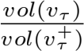, where gvτ is the sum of the weights

of all the edges between nodes in Tvτ and outside Tvτ , and vol (vτ ) is Σv∈Tv τ vol (v). The D-dimensional structural entropy of G can be defned as HD (G) = minT Σvτ ∈T,vτ vr HT (G;vτ ), where T represents the set of encoding trees with heights at most D.

The encoding tree is constructed by iteratively merging the leaf nodes to minimize the structural entropy until a bi- nary tree is formed. However, directly constructing an en- coding tree may not yield appropriate clustering partitions. This may arise from the signifcant imbalance between the number of nodes in the encoding tree and the number of pre- defned clusters for partitioning. To achieve improved clus- tering partitions, we aim to limit the height of the encod- ing tree to a pre-defned tree height D, where a tree-height restriction approach is proposed. The tree-height restriction approach mainly consists of three operations: the COM- BINE, the DROP, and the SINGUP. Intuitively, the COM- BINE operation aims to minimize the structural entropy dur- ing tree construction, the DROP operation aims to reduce the tree height of the encoding tree to satisfy certain height con- straint with minimum increase in structural entropy, and the SINGUP operation aims to adjust the encoding tree to the specifed tree height without additional increase in structural entropy.

**Defnition 1** *Given two vertexes* v, v ∈ Vr−*, the oper-*

*ation* **COMBINE** (v, v) *is defned as creating a child*

*node* vτ *for* vr *to serve as the parent node for* v *and* v*,*

*where* Tvτ = Tv + Tv *. The operation* **DROP**(vτ ) *is de-*

*fned as removing the node* vτ *from* T *and connecting the*

*children of* vτ *to its parent, where* Tv = Tv Tvτ *. Given a leaf node*vi ∈ V*, the operation* **SINGUP**(vi , D) *is de-*

*fned as adding anode* v *as the parent of* vi *and the child of*

v vi *is* D*, where* Tv = Tvi *.*

The specifc encoding tree construction process is given in Algorithm 3. Based on the proposed tree operations, Al- gorithm 3 can be divided into three stages.

**STAGE 1.** In stage 1 (steps 2 to 3), the algorithm ex- plores all possible COMBINE operations to determine the best one that yields the maximal reduction in structural en-

tropy. Then, two children v and v are merged to form a

new tree node. In Algorithm 3, COMBINE operations are repeated until |Vr− | < 3. Finally, a binary encoding tree T can be obtained.

**STAGE 2.** In stage 2 (steps 5 to 6), all possible DROP operations are explored to reduce the height. We use T**DROP**(vτ ) to denote the encoding tree that is obtained af- ter performing the operation **DROP**(vτ ). Then, we repeat stage 2 until the height of the encoding tree is no larger than D. If there exists a node v not satisfying the height con- straint, using **DROP** operations might reduce the height of the children of v. As a result, there might exist some leaf nodes with different heights. Thus, the remaining task in-

The Thirty-Eighth AAAI Conference on Artiﬁcial Intelligence (AAAI-24)

Algorithm 3: EncodingTree

**Input:** Graph G = (V,E, W), tree depth D > 1.

**Output:** A vector of structural entropy for the data points.

1: Build an initial encoding tree T with a root node vr , and each leaf node of vr corresponds to a unique vertex in V as one of its children;

2: **while** |Vr− | > 2 **do**

3: COMBINE (v, v) ← arg max(v,v) {HT (G) − HT**COMBINE** (v,v) (G)|v, v ∈ Vr− };

*where* − · − *is the dot product of the vectors and* d(B, C)

4: **end while**

5: **while** Height(T) > D **do**

6: DROP(vτ ) ← arg minvτ {HT**DROP**(vτ) (G) − HT (G)|vτ ∈ T&vτ  vr &vτ  V };

7: **end while**

8: **for all** vi ∈ V **do**

9: If Depth(T, vi ) < D, then Call **SINGUP**(vi , D); 10: **end for**

11: **for all** i ∈ {1, 2,..., n} **do**

12: Find a path P = [vi,..., vr ] in encoding tree T from vi to the root vr ;

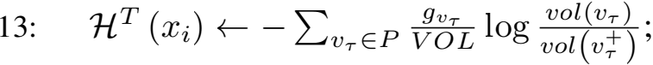

14: **end for**

15: **return** [HT (x1 ) , HT (x2 ) , . . . , HT (xn )]T ;

volves adjusting the heights of the leaf nodes to ensure that all the leaf nodes share the same height.

**STAGE 3.** In this stage, we use the SINGUP operation to simultaneously modify all leaf nodes to restrict their height to the specifed parameter D without increasing the struc- tural entropy of the graph partitions. The time complexity for the SINGUP operation is O(nD), where D is the speci- fed height after adjustment, and n is the number of vertices in the graph.

To this end, we have introduced how to obtain structural entropy for both the graph G and the nodes in the encoding tree. For the clustering problem, we will next introduce the defnition of structural entropy for a data point to achieve the hierarchical abstraction of the entire dataset.

**Defnition 2** *Given an encoding tree* T*, for each data point* xi ∈ X *corresponding a leaf node* vi ∈ T*, there exists a unique path* P = [vi,..., vr ] *from* vi *to the root node* vr*. The structural entropy of data point* xi *is defned as the cu- mulativesum of the entropy associated with each node along*

*the path* P*, where* HT  = −Σvτ ∈P 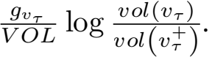

Based on the three tree operations defned and the struc- tural entropy of data points, a modifed encoding tree can be constructed using Algorithm 3, where a vector of global features is constructed for each data point in the dataset.

**Iterative Pre-deletion and Reassignment**

For the clustering problem, it is observed that most mis- clustered data points are located at the boundaries consist- ing of distinct clustering partitions, which we refer to as the fringe points. Fringe points can lead to signifcant de- viation of the clustering boundaries. To avoid the impact of

the fringe points and obtain better clustering partitions, we

propose an iterative pre-deletion and reassignment method,

which can iteratively delete and reassign the fringe points

during the clustering process. The fringe points are defned

using the projective distance, which is given in Defnition 3.

**Defnition 3** *Given a point* A *and a vector* −*from point* B

*to point* C*, the projective distance* Pd *between point* A *and*

*vector* − *is defned as* Pd(A,−) = − · −/d(B, C)*,*

*is the Euclidean distance between points* B *and* C*.*

Based on projective distance, the fringe set is defned in Defnition 4. In the clustering process, Algorithm 4 can iden- tify and exclude the fringe set before each clustering cen- ter updating step. To avoid signifcant deviation from the ground truth clustering partitions, the algorithm fnds the midpoints between the updated centers with and without the fringe set as the new centers. After updating the clustering centers, data points in the fringe set are randomly assigned to the obtained centers to achieve better clustering results. **Defnition 4** *Consider a dataset* X ⊆ Rd *and a set* C ⊆ Rd *of centers, where* X = {xi |i ∈ [n]} *and* C = {cj |j ∈ [k]}*, let* chi *be the center to which* xi *is assigned. The set of points, denoted by* {xi |Pd(xi ,  [n], j ∈ [k], j  hi }*, forms what is called a fringe set, and the points in the fringe set are called fringe points, where* δ *is a constant specifed by the input of the algorithm.*

|  |  |
| --- | --- |
| Algorithm 4: IterativeDeletion | |
| **Input:** Data points X = {xi |i = 1, 2,..., n}, the number of clusters k, and the “fringe set” region parameter δ .  **Output:** Labels of the clustering partitions.  1: Let C = {c1,..., ck } and L = (l1,..., ln ) be the set of the centers and labels returned by the k-means++ algo- | |
| rithm, respectively;  2: Initialize CnF , CF , C′ ← C and LnF , LF , L′ , ← L; | |
| 3: | **while** True **do** |
| 4: | **for all** i = 1, 2, . . . ,n **do** |
| 5: | Let chi be the center that xi is assigned to; |
| 6: | **for all** j = 1, 2,...,k **do** |
| 7: | If Pd(xi , ) > hi , cj ) and j  h, |
| 8: | l ← 0 and l ← 1;  **end for** |
| 9: | **end for** |
| 10: | **for all** j = 1, 2,...,k **do** |
| 11: | F ←  ←  ← |
| 12: | c+c  2 ;  **end for** |
| 13: | Update the labels L′ = (l,..., l) as l = (l1,..., lk ), where lj = 1 if j = arg minj∈[k] d(xi , c), otherwise lj = 0; |
| 14: | If L′  L, LnF ,LF , L ← L′ . Otherwise, stop the while loop; |
| 15: | **end while** |
| 16: | **return** L; |

The Thirty-Eighth AAAI Conference on Artiﬁcial Intelligence (AAAI-24)

**Experiment**

In this section, we conduct empirical experiments on dif- ferent synthetic and real-world datasets to evaluate the per- formance of our proposed SEC algorithm. All the experi- ments are conducted on 72 Intel Xeon Gold 6230 CPUs with 500GB memory.

**Algorithms.** In our experiment, we consider six algorithms: our SEC algorithm, the k-means++ algorithm (denoted as KM) in (Arthur and Vassilvitskii 2007), the fuzzy k-means algorithm (denoted as FK) in (Ruspini 1969) (a variation of the k-means algorithm which assigns each point to the cen- ter with probability), the DBSCAN algorithm (denoted as DB) in (Ester et al. 1996) (a classic density-based method), the LDP-MST algorithm (denoted as LM) in (Cheng et al. 2019) (the state-of-the-art MST and density-based cluster- ing method), and the HCDC algorithm (denoted as HC) in (Yang et al. 2023) (the state-of-the-art algorithm for hierar- chical clustering methods).

**Datasets.** We evaluate the effectiveness of our algorithm on both synthetic and real-world datasets. Following the prior work (Arthur and Vassilvitskii 2007; Ester et al. 1996; Cheng et al. 2019; Yang et al. 2023), synthetic datasets are two-dimensional, and all the real-world datasets can be found in the UCI machine learning repository 1 .

**Experimental Setup.** The distances between data points are set as Euclidean distances. Following the settings in (Arthur and Vassilvitskii 2007; Ester et al. 1996; Cheng et al. 2019; Yang et al. 2023), we run all the algorithms on each dataset for fve times and report the average results. For our algo- rithm, we also study the infuence of structural entropy and design an ablation experiment to show the impact of iterative construction of the encoding tree and iterative pre-deletion of the fringe set (see the full version).

**Evaluation.** Following the settings in (Arthur and Vassil- vitskii 2007; Ester et al. 1996; Cheng et al. 2019; Yang et al. 2023), we use two external evaluation criteria: ac- curacy (ACC) and normalized mutual information (NMI). With ACC, we can evaluate the percentage of correctly as- signed data points. For NMI, it measures the similarity be- tween the clustering results and the true partitioning of the datasets.

**Experiment on Synthetic Datasets.** The synthetic datasets are summarized in Table 1. For each dataset X , the fringe set ratio is measured as the number of fringe points relative to the data size, denoted as FR = |FP|/|X| in the table.

|  |  |  |  |
| --- | --- | --- | --- |
| Datasets | Instances | Clusters | FR |
| square5 | 1000 | 4 | 0.133 |
| compound | 399 | 6 | 0.318 |
| ds4c2sc8 | 462 | 8 | 0.050 |
| threenorm | 1000 | 2 | 0.153 |
| aggre | 788 | 7 | 0.039 |
| 2d-3c-no123 | 715 | 3 | 0.010 |
| 2d-20c-no0 | 1517 | 20 | 0.010 |
| s4 | 5000 | 15 | 0.202 |
| sizes5 | 1000 | 4 | 0.018 |

Table 1: Synthetic datasets

1<https://archive.ics.uci.edu>

|  |  |  |  |  |  |  |
| --- | --- | --- | --- | --- | --- | --- |
| Data | KM | FK | DB | HC | LM | Ours |
| square5 | 0.865 | 0.865 | 0.733 | 0.278 | 0.556 | **0.868** |
| compound | 0.654 | 0.659 | 0.699 | **0.995** | 0.807 | 0.972 |
| ds4c2sc8 | 0.760 | 0.903 | 0.656 | 0.589 | 0.762 | **0.961** |
| threenorm | 0.672 | 0.646 | 0.823 | 0.514 | 0.623 | **0.896** |
| aggre | 0.784 | 0.792 | 0.990 | 0.996 | 0.997 | **1.0** |
| 2d3cno123 | 0.867 | 0.794 | 0.964 | 0.994 | 0.917 | **0.997** |
| 2d20cno0 | 0.941 | 0.860 | 0.978 | 0.994 | 0.962 | **0.995** |
| s4 | 0.795 | 0.8 | 0.5328 | 0.288 | 0.662 | **0.806** |
| sizes5 | 0.978 | 0.689 | 0.965 | 0.991 | 0.991 | **0.997** |

Table 2: Results of ACC scores on synthetic datasets

Tables 2 and 3 show the comparison results on 9 synthetic datasets. Our SEC algorithm outperforms others in cluster- ing ACC on 8 datasets. On average, SEC improves ACC by 17.8%, 22.9%, 19.3%, 58.7%, and 20.2% over k-means++, fuzzy k-means, DBSCAN, HCDC, and LDP-MST, respec- tively. By fxing the state-of-the-art result as a reference, the average ACC is increased by 1.7%. Similarly, for NMI, the average clustering NMI of our SEC algorithm is increased by 61.5%, 98.0%, 26.5%, 311.7%, and 49.1%,respectively. By fxing the state-of-the-art result as a reference, the aver- age NMI is increased by 7.9%.

|  |  |  |  |  |  |  |
| --- | --- | --- | --- | --- | --- | --- |
| Data | KM | FK | DB | HC | LM | Ours |
| square5 | 0.642 | 0.641 | 0.461 | 0.073 | 0.406 | **0.649** |
| compound | 0.718 | 0.711 | 0.641 | **0.987** | 0.852 | 0.935 |
| ds4c2sc8 | 0.748 | 0.846 | 0.690 | 0.726 | 0.815 | **0.921** |
| threenorm | 0.097 | 0.066 | 0.328 | 0.026 | 0.122 | **0.520** |
| aggre | 0.879 | 0.849 | 0.979 | 0.988 | 0.992 | **1.0** |
| 2d3cno123 | 0.720 | 0.611 | 0.850 | 0.965 | 0.806 | **0.984** |
| 2d20cno0 | 0.963 | 0.936 | 0.980 | 0.991 | 0.981 | **0.993** |
| s4 | 0.720 | 0.721 | 0.589 | 0.386 | 0.688 | **0.731** |
| sizes5 | 0.884 | 0.566 | 0.837 | 0.943 | 0.941 | **0.977** |

Table 3: Results of NMI scores on synthetic datasets

**Real-World Datasets.** Table 4 summarizes the real-world datasets used in our experiments. Table 5 and Table 6 show the comparison results on the real-world datasets.

|  |  |  |  |  |
| --- | --- | --- | --- | --- |
| Datasets | Instances | Dimensions | Clusters | FR |
| iris | 150 | 4 | 3 | 0.073 |
| wine | 178 | 13 | 3 | 0.275 |
| glass | 214 | 9 | 6 | 0.519 |
| PenDigits | 10992 | 16 | 10 | 0.185 |
| Yeast | 1484 | 8 | 10 | 0.499 |
| segment | 2310 | 19 | 7 | 0.277 |
| control | 600 | 60 | 6 | 0.148 |

Table 4: Real-world datasets

It can be seen from Tables 5 and 6 that our SEC algorithm outperforms the existing clustering algorithms on all of the real-world datasets used in our experiments. By calculating the average values over all datasets, on average, SEC im- proves ACC by 21.9%, 28.8%, 25.1%, 43.2%, and 29.3% over k-means++, fuzzy k-means, DBSCAN, HCDC, and LDP-MST, respectively. The NMI improvements are 19.3%,

The Thirty-Eighth AAAI Conference on Artiﬁcial Intelligence (AAAI-24)

47.4%, 34.7%, 52.2%, and 18.9%, respectively. In particu- lar, for more than half of the datasets used in the experi- ments, the clustering ACC and NMI are increased by 20.6% and 9.8%, respectively. In the full version, we present the experimental results of 92 synthetic and real-world datasets used in other clustering methods in the related work. On av- erage, our SEC algorithm improves the ACC and NMI by 3.09% and 18.82%,respectively.

|  |  |  |  |  |  |  |
| --- | --- | --- | --- | --- | --- | --- |
| Data | KM | FK | DB | HC | LM | Ours |
| iris | 0.893 | 0.893 | 0.893 | 0.907 | **0.973** | **0.973** |
| wine | 0.944 | 0.697 | 0.668 | 0.562 | 0.983 | **0.989** |
| glass | 0.542 | 0.495 | 0.491 | 0.407 | 0.449 | **0.626** |
| PenDigits | 0.667 | 0.684 | 0.741 | 0.532 | 0.744 | **0.812** |
| Yeast | 0.377 | 0.327 | 0.389 | 0.396 | 0.416 | **0.428** |
| segment | 0.501 | 0.493 | 0.530 | 0.452 | 0.552 | **0.770** |
| control | 0.645 | 0.737 | 0.687 | 0.648 | 0.408 | **0.872** |

Table 5: Results of ACC scores on real-world datasets

|  |  |  |  |  |  |  |
| --- | --- | --- | --- | --- | --- | --- |
| Data | KM | FK | DB | HC | LM | Ours |
| iris | 0.758 | 0.893 | 0.734 | 0.806 | **0.901** | **0.901** |
| wine | 0.816 | 0.421 | 0.416 | 0.299 | 0.928 | **0.947** |
| glass | 0.418 | 0.355 | 0.436 | 0.307 | 0.284 | **0.534** |
| PenDigits | 0.682 | 0.638 | 0.729 | 0.651 | 0.770 | **0.779** |
| Yeast | 0.271 | 0.176 | 0.2 | 0.246 | 0.256 | **0.295** |
| segment | 0.510 | 0.477 | 0.602 | 0.564 | 0.686 | **0.687** |
| control | 0.726 | 0.679 | 0.821 | 0.816 | 0.671 | **0.868** |

Table 6: Results of NMI scores on real-world datasets

**Discussion on Experiments.** To better show the results of the SEC algorithm, we mainly divide the datasets into four categories: (1) Type-1: datasets with stripe-like shape and without fringe sets; (2) Type-2: datasets with fringe sets and without stripe-like shape; (3) Type-3: datasets with fringe sets and stripe-like shape; (4) Type-4: datasets with- out stripe-like shape and fringe sets. Figure 3 provides an illustration of typical examples for each type of the dataset.

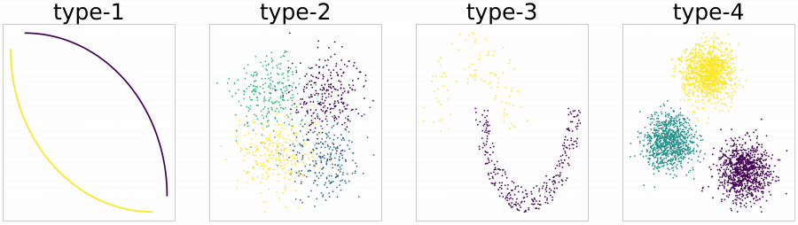

Figure 3: Typical examples for each type of the datasets

Table 7 summarizes the statistical analysis for different types of datasets used in the experiments. We report the number of each type of dataset, the ACC and NMI improve- ments using the SEC algorithm, and the number of datasets where the SEC algorithm fnds optimal clustering partitions

|  |  |  |  |  |
| --- | --- | --- | --- | --- |
|  | numbers | ACC boost | NMI boost | count of opt |
| type-1 | 5 | - | - | 5 |
| type-2 | 20 | 2.720% | 5.169% | 5 |
| type-3 | 34 | 2.391% | 47.260% | 21 |
| type-4 | 47 | 5.060% | 1.240% | 21 |

Table 7: Statistical analysis of the experimental results

Figure 4 demonstrates the impact of structural entropy on clustering quality, where the visualization for four of the two-dimensional datasets with stripe-like shapes and with- out fringe sets is provided. We give plots of the raw datasets and the datasets after incorporating structural entropy. The k-means algorithm achieves ACCs of 0.25, 0.702, 0.706, and 0.7406, respectively; and our algorithm achieves 1, 1, 1, and 1, respectively. It can be seen that the four datasets do not have distinct Voronoi structures. As pointed out in (Reddy, Jana, and Member 2012), it is hard fork-means al- gorithms to get high-quality results on these datasets. The new datasets, obtained after dimensionality expansion using structural entropy, exhibit distinct Voronoi structures, which is the main reason that high-quality results can be obtained.

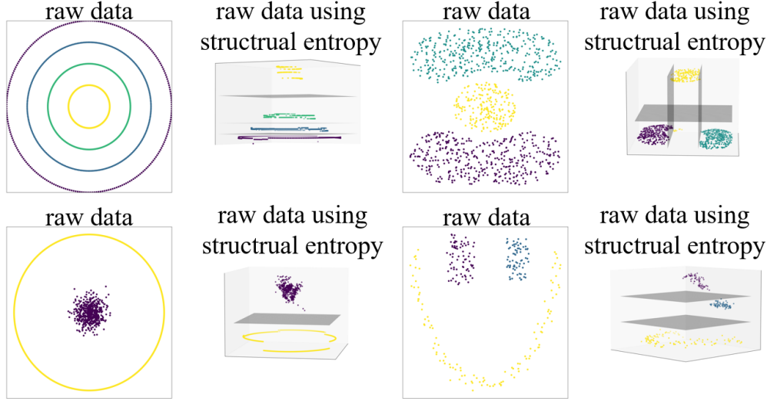

Figure 4: Comparisons of datasets with and without global structural features

**Conclusion**

In this work, we propose a new clustering method called SEC, which uses structural entropy to obtain global struc- tural features to guide the clustering process. Moreover, a pre-deletion and reassignment method is used in SEC to handle datasets with fringe sets to obtain better clustering performance. Experimental results show that our proposed SEC method outperforms other state-of-the-art clustering al- gorithms in terms of clustering quality.

**Acknowledgments**

This work was supported by National Natural Science Foun- dation of China (62172446, 62350004, 62332020), Open Project of Xiangjiang Laboratory (22XJ02002, 22XJ03005), and Central South University Research Programme of Advanced Interdisciplinary Studies (2023QYJC023). This work was also carried out in part using computing resources at the High Performance Computing Center of Central South University.

The Thirty-Eighth AAAI Conference on Artiﬁcial Intelligence (AAAI-24)

**References**

Ankerst, M.; Breunig, M. M.; Kriegel, H.-P.; and Sander, J. 1999. OPTICS: Ordering points to identify the clustering structure. *ACM Sigmod Record*, 28(2): 49–60.

Arthur, D.; and Vassilvitskii, S. 2007. k-means++: the ad- vantages of careful seeding. In *Proceedings of the 18thAn- nualACM-SIAM Symposium on Discrete Algorithms*, 1027– 1035.

Bhattacharjee, P.; and Mitra, P. 2021. A survey of density based clustering algorithms. *Frontiers of Computer Science*, 15: 1–27.

Blmer, J.; Lammersen, C.; Schmidt, M.; and Sohler, C. 2016. Theoretical analysis of the k-means algorithm - a sur- vey. In *Algorithm Engineering: Selected Results and Sur- veys*, volume 9220, 81–116. Springer.

Campello, R. J. G. B.; Moulavi, D.; and Sander, J. 2013. Density-based clustering based on hierarchical density esti- mates. In *Proceedings of the 18th Pacifc-Asia Knowledge Discovery and Data Mining*, volume 7819, 160–172.

Cheng, D.; Zhu, Q.; Huang, J.; Wu, Q.; and Yang, L. 2019. Clustering with local density peaks-based minimum span- ning tree. *IEEE Transactions on Knowledge and Data En- gineering*, 33(2): 374–387.

Chowdhury, N.; and Murthy, C. 1997. Minimal spanning tree based clustering technique: relationship with bayes clas- sifer. *Pattern Recognition*, 30(11): 1919–1929.

Du, H.-Y.; and Wang, W.-J. 2022. A clustering ensemble framework with integration of data characteristics and struc- ture information: a graph neural networks approach. *Math- ematics*, 10(11): 1834.

Ester, M.; Kriegel, H.; Sander, J.; and Xu, X. 1996. A density-based algorithm for discovering clusters in large spatial databases with noise. In *Proceedings of the 2nd In- ternational Conference on Knowledge Discovery and Data Mining*, 226–231.

Gracia, C.; and Binefa, X. 2011. On hierarchical cluster- ing for speech phonetic segmentation. In *Proceedings of the 19th European Signal Processing Conference*, 2128–2132. Hou, J.; Gao, H.; and Li, X. 2016. DSets-DBSCAN: A parameter-free clustering algorithm. *IEEE Transactions on Image Processing*, 25(7): 3182–3193.

Huang, W.; Peng, Y.; Ge, Y.; and Kong, W. 2021. A new Kmeans clustering model and its generalization achieved by joint spectral embedding and rotation. *PeerJ Computer Sci- ence*, 7: e450.

Lattanzi, S.; and Sohler, C. 2019. A better k-means++ al- gorithm via local search. In *Proceedings of the 33rd In- ternational Conference on Machine Learning*, volume 97, 3662–3671.

Li, A.; and Pan, Y. 2016. Structural information and dynam- ical complexity of networks. *IEEE Transactions on Infor- mation Theory*, 62(6): 3290–3339.

Li, Y.; and Wu, H. 2012. A clustering method based on K- means algorithm. *Physics Procedia*, 25: 1104–1109.

Lloyd, S. P. 1982. Least squares quantization in PCM. *IEEE Transactions on information Theory*, 28(2): 129–136.

Mawati, R.; Sumertajaya, I. M.; and Afendi, F. M. 2014. Modifed centroid selection method of K-means clustering. *IOSR Journal of Mathematics*, 10(2): 49–53.

Nainggolan, R.; Perangin-angin, R.; Simarmata, E.; and Tarigan, A. F. 2019. Improved the performance of the K- Means cluster using the sum of squared error (SSE) opti- mized by using the elbow method. *Journal of Physics: Con- ference Series*, 1361(1): 012015.

Ram,A.; Sunita,J.; Jalal,A.; and Manoj, K. 2010. A density based algorithm for discovering density varied clusters in large spatial databases. *International Journal of Computer Applications*, 3: 1–4.

Reddy, D.; Jana,P. K.; and Member, I. S. 2012. Initialization for K-means clustering using voronoi diagram. *Procedia Technology*, 4: 395–400.

Ruspini, E. H. 1969. A new approach to clustering. *Infor- mation and Control*, 15(1): 22–32.

Sneath, P. H. A. 1973. The principles and practice of numer- ical classifcation. *Numerical Taxonomy*, 573.

Steinbach, M.; Karypis, G.; and Kumar, V. 2000. A compar- ison of document clustering techniques. *Technical Report*. Yang, J.; Wang, Y.-K.; Yao, X.; and Lin, C.-T. 2021. Adap- tive initialization method for K-means algorithm. *Frontiers in Artifcial Intelligence*, 4: 740817.

Yang, Q.-F.; Gao, W.-Y.; Han, G.; Li, Z.-Y.; Tian, M.; Zhu, S.-H.; and Deng, Y.-h. 2023. HCDC: A novel hierarchi- cal clustering algorithm based on density-distance cores for data sets with varying density. *Information Systems*, 114: 102159.

Zahn, C. T. 1971. Graph-theoretical methods for detecting and describing gestalt clusters. *IEEE Transactions on Com- puters*, 100(1): 68–86.

Zhou, X.; Gu, J.; Shen, S.; Ma, H.; Miao, F.; Zhang, H.; and Gong, H. 2017. An automatic k-means clustering al- gorithm of GPS data combining a novel niche genetic algo- rithm with noise and density. *ISPRS International Journal of Geo-Information*, 6(12): 392.